**Name:**

**Programming I**

**Lab Exercise 1.7.2022**

**Problem 1**

**A Circle and Two Squares**

Imagine a circle and two squares: a smaller and a bigger one. For the smaller one, the circle is a circumcircle and for the bigger one, an incircle.

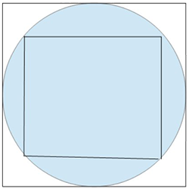

Create a function, that takes an integer (radius of the circle) and returns the difference of the areas of the two squares.

**Examples**

square_areas_difference(5) ➞ 50

square_areas_difference(6) ➞ 72

square_areas_difference(7) ➞ 98

**Notes**

Use only positive integer parameters.

**Problem 2**

**Classes For Fetching Information on a Sports Player**

Create a class that takes the following four arguments for a particular football player:

* name
* age
* height
* weight

Also, create three functions for the class that returns the following strings:

* get_age() returns "name is age age"
* get_height() returns "name is heightcm"
* get_weight() returns "name weighs weightkg"

### Examples

p1 = Player("David Jones", 25, 175, 75)

p1.get_age() ➞ "David Jones is 25 years"

p1.get_height() ➞ "David Jones is 175 cm"

p1.get_weight() ➞ "David Jones weighs 75 kg"

#### Notes

name will be passed in as a string and age, height, weight will be integers.

**Problem 3**

**Two Distinct Elements**

In each input list, every number **repeats at least once**, except for **two**. Write a function that returns the **two unique numbers**.

### Examples

return_unique([1, 9, 8, 8, 7, 6, 1, 6]) ➞ [9, 7]

return_unique([5, 5, 2, 4, 4, 4, 9, 9, 9, 1]) ➞ [2, 1]

return_unique([9, 5, 6, 8, 7, 7, 1, 1, 1, 1, 1, 9, 8]) ➞ [5, 6]

### Notes

Keep the same ordering in the output.